Homework help

And Retests

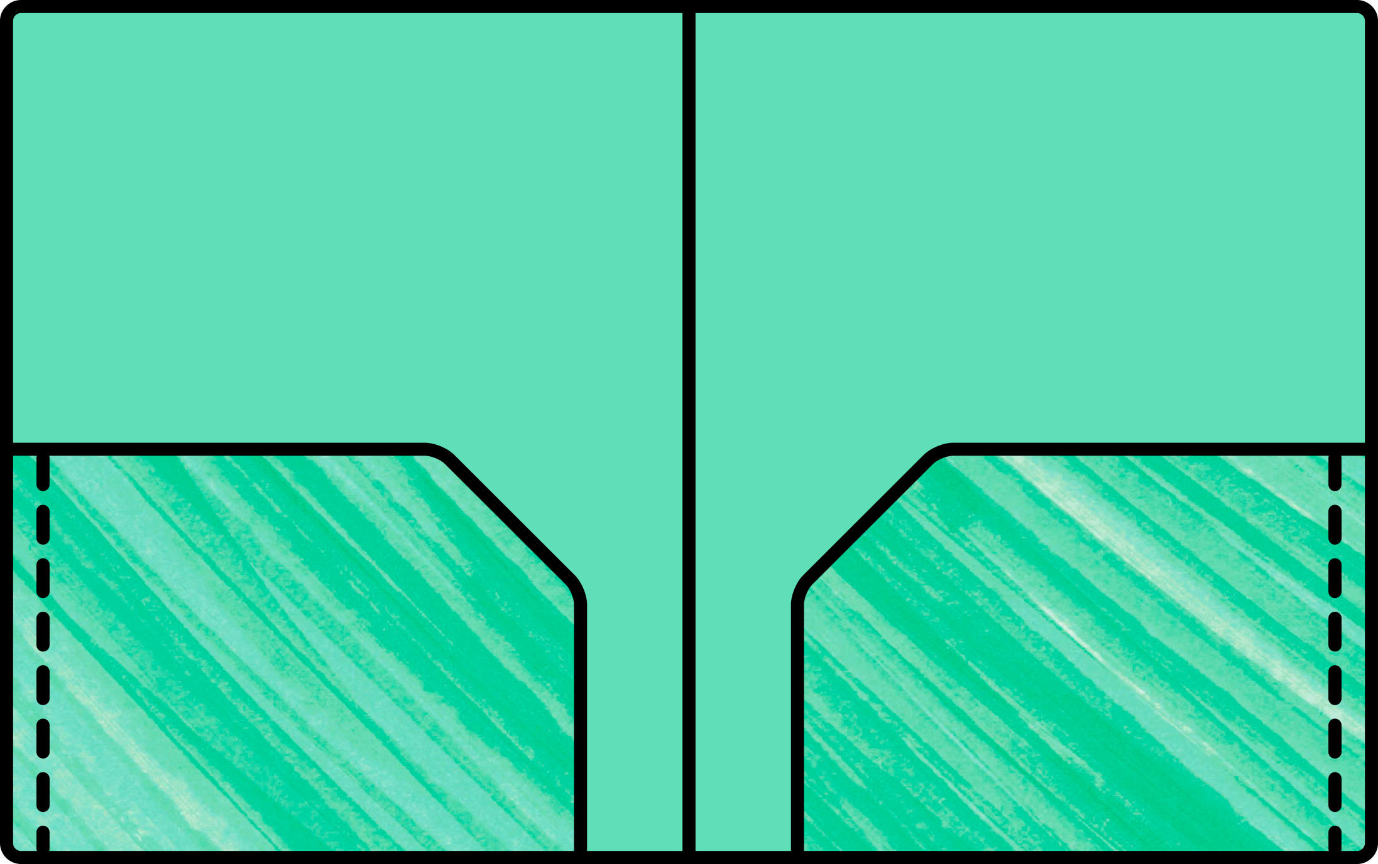

-If you are struggling with a homework assignment, please use our google classroom page to post questions along with a picture of your work so far so I or other students can help guide you in the right direction. I will also announce any available study hall days for you to come and get help.

-Retests are available for unit tests only. I will drop the lowest quiz for each trimester. Corrections should be completed on a separate piece of paper and original tests should have a parent signature. Please see me to arrange date and time for retest.

Paper Headings:

(Right Side)

First and Last Name

Date

SLE

(left Side)

Assignment name, page, and problem numbers

Math Syllabus

2019-2020

Single Subject Spiral Notebook

1 Composition book

Scissors and liquid glue

Pencils, erasers, and colored pens

Whiteboard with Dry erase markers

Loose leaf paper (lined and graph)

*may need more than 1

**Behavior:**

**Issues with behavior will always be addressed with you first. Your actions should never distract you or your peers from learning or disrupt my teaching.**

1. Verbal warning
2. Behavior Think Sheet, move seats if needed
3. Behavior Think Sheet sent home, contact parents

Supply List:

 

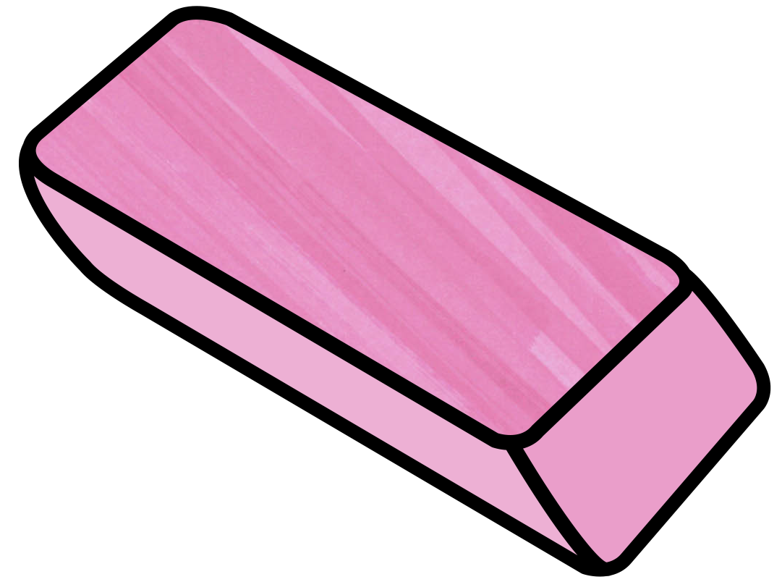

**Grading:**

Lions Learning Time 5%

Interactive Notebooks 15%

Homework 15%

Classwork 20%

Quizzes 20%

Tests 25%

Classroom Rules:

* Respect yourself
* Respect your peers
* Respect your teachers
* Respect your school community

Homework Policy:



**Late Work**: Assignments are typically due the day after they are assigned. It is your responsibility to manage your due dates for all classes and be timely in your work. Work will only be accepted during the unit in which it was assigned for 50% credit. If you consistently turn in late work, your parent and/or administrators may become involved.

**Absent Work**: If you are absent, materials you missed will be posted on the absent board. It is your responsibility to catch up on any notes, INB pages, and classwork in addition to the homework.

**Re-dos**: Assignments with a score of 64% or below will be considered a “redo”. You need to redo the problems that you got wrong on a separate piece of paper and turn in with the original assignment. I will average your score if you get the majority of them correct.

*work must be shown, papers with just answers will not receive any credit*

**Interactive Notebook pages:** INB pages that are not completed during the class period or due to an absence need to be completed within a week of the absence for full credit. After this, the pages completed before the end of the unit will receive 50% credit.



Contact Information:

Mrs. Melissa Bocanegra

[Grade7@stluketemplecity.org](mailto:Grade7@stluketemplecity.org)

626-291-5959

